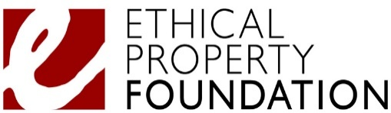

How to read a lease – Free webinar for charities
The Ethical Property Foundation (EPF) is pleased to announce their 2026 webinar series. As the UK’s leading property advice charity for the voluntary sector, they are offering a free webinar to help charities and community groups understand leases and manage property risks.
Join them for an engaging and practical session that will strengthen your organisation’s property strategy.

Webinar details
📅 Date: Thursday 5th February 2026
⏰ Time: 12:00 – 1:00 p.m.
📍 Location: Zoom

What you’ll learn
Expert solicitors and surveyors will explain how to read and understand a lease. You’ll come away feeling more confident about signing a lease and knowing your rights and responsibilities. This session will help you:
✔️ Understand what a lease is, what it includes, and why it matters
✔️ Read a lease clearly, with simple explanations of common terms
✔️ Recognise security of tenure and why the Landlord & Tenant Act 1954 matters
✔️ Understand repairing obligations such as FRI/IRI leases
✔️ Navigate rules on use, alterations and getting landlord consent
✔️ Understand assignment, subletting and sharing space
✔️ Make sense of break clauses, rent reviews and key dates to diarise
✔️ Apply practical top tips to manage your lease effectively and avoid common pitfalls

Exclusive resources
After the session, you’ll receive a helpful information pack. You’ll also be able to access free follow-up advice through our Ask a Property Expert service.

Why attend?
Since 2003, the Ethical Property Foundation has helped thousands of voluntary organisations make better property decisions. As the official referral partner to the Charity Commission for land and property advice, they’re here to support you.

Register now
Don’t miss out – click here to register on Eventbrite and secure your free place today.

Acknowledgements
Grateful for the support of City Bridge Foundation and Turley, who have made this webinar possible.

