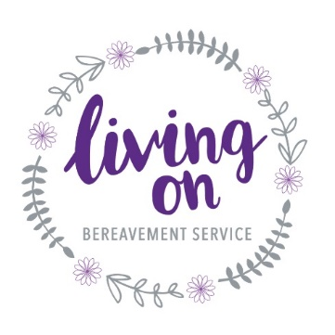

VACANCY – FAMILY SUPPORT WORKER

Living On is excited to be expanding our clinical team following the award of a grant from the National Lottery Community Fund to fund a new post. We are recruiting for a Family Support Worker who has experience of working with children and young people and who has an understanding and knowledge of childhood bereavement. We are based in Orpington, BR6 and we support families in and around this area. We offer children a therapeutic space to explore creatively their grief and their story. We provide these sessions individually and in group settings, as well as “holding” the whole family during this process. We strive to encourage the local community to talk about death and dying and offer advice and reassurance in walking alongside the bereaved families in our community and schools. The hours are 18 hours a week with some evening and weekend availability required.

If you would be interested in finding out more about this post please email us at admin@livingon.org.uk for a copy of the job description. The application process will require the submission of a CV and a covering letter. We hope to hold interviews in July

