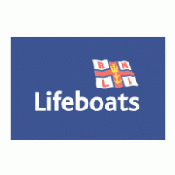Thames Walk in July to raise funds for an essential upgrade to the Tower Lifeboat Station for its crew.
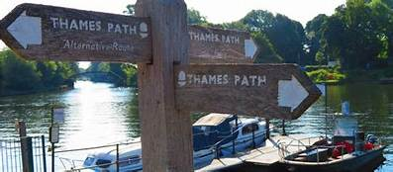
On Saturday 24th July the Bromley, West Wickham amd Hayes RNLI Fundraising Branch are walking the Thames Path
You are invited to walk on the Thames Path as far as you want to go. It could be from Teddington, Barnes Bridge, or even closer to the Lifeboat Station on Victoria Embankment. You can choose when to walk but we would love you to walk by 31st July. Please contact cd.sutcliffe@outlook.com for an information pack if you would like to participate.
Donations can be made at
https://www.justgiving.com/fundraising/rnlibromleythamespathchallenge
Or contact our Treasurer - Charles_m_raphael@hotmail.com
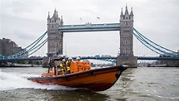
The RNLI is the charity that saves lives at sea. Royal National Lifeboat Institution, a charity registered in England and Wales (209603) and Scotland (SC037736). Registered charity number 20003326 in the Republic of Ireland

